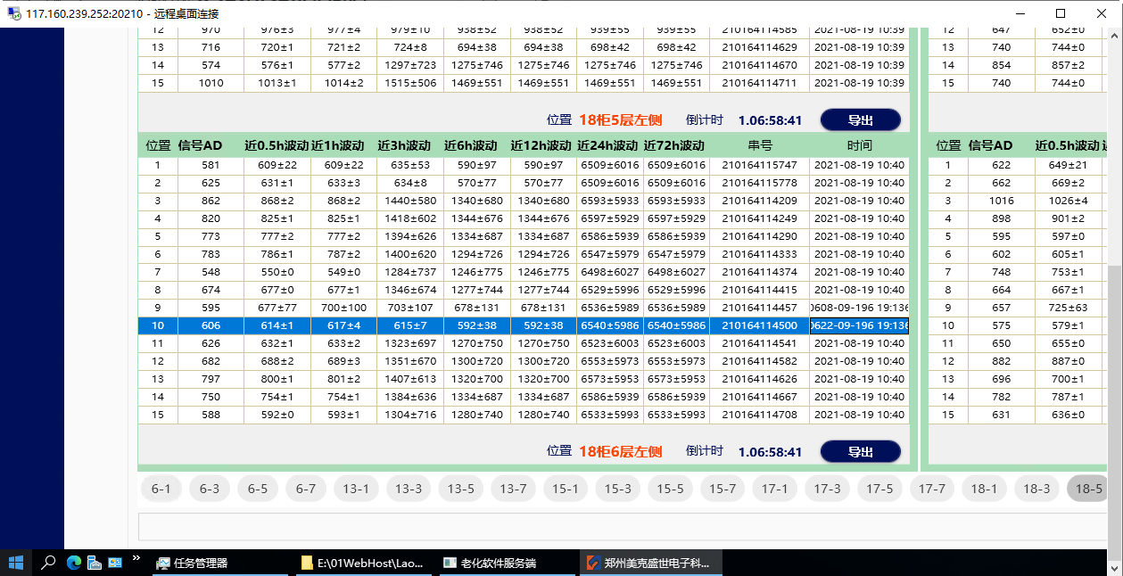

202108180113130 2021081801 家用可燃气体报警器-ASD5335-安仕德 10000417 家用可燃气体报警器-ASD5335-安仕德 1131 1013 210164115299 30 2021-08-18 20:53:19 2157-25-45 45:85 2021-08-19 10:39:37
202108180118609 2021081801 家用可燃气体报警器-ASD5335-安仕德 10000417 家用可燃气体报警器-ASD5335-安仕德 1186 1018 210164114457 9 2021-08-19 10:35:20 0608-09-196 19:136 2021-08-19 10:39:49
202108180118610 2021081801 家用可燃气体报警器-ASD5335-安仕德 10000417 家用可燃气体报警器-ASD5335-安仕德 1186 1018 210164114500 10 2021-08-19 10:35:20 0622-09-196 19:136 2021-08-19 10:39:49
202108180118623 2021081801 家用可燃气体报警器-ASD5335-安仕德 10000417 家用可燃气体报警器-ASD5335-安仕德 1186 1018 210164115017 23 2021-08-18 20:55:11 2085-25-33 45:44 2021-08-19 10:39:37
202108180118709 2021081801 家用可燃气体报警器-ASD5335-安仕德 10000417 家用可燃气体报警器-ASD5335-安仕德 1187 1018 210164115716 9 2021-08-19 10:35:23 0876-09-196 19:136 2021-08-19 10:39:49
202108180118710 2021081801 家用可燃气体报警器-ASD5335-安仕德 10000417 家用可燃气体报警器-ASD5335-安仕德 1187 1018 210164115748 10 2021-08-19 10:35:23 0723-09-196 19:136 2021-08-19 10:39:49
202108180118809 2021081801 家用可燃气体报警器-ASD5335-安仕德 10000417 家用可燃气体报警器-ASD5335-安仕德 1188 1018 210164114461 9 2021-08-18 20:55:06 0803-09-196 19:136 2021-08-19 10:39:49
202108180118810 2021081801 家用可燃气体报警器-ASD5335-安仕德 10000417 家用可燃气体报警器-ASD5335-安仕德 1188 1018 210164114504 10 2021-08-18 20:55:06 0866-09-196 19:136 2021-08-19 10:39:49

202108180106309 2021081801 家用可燃气体报警器-ASD5335-安仕德 10000417 家用可燃气体报警器-ASD5335-安仕德 1063 1006 210164115936 9 2021-08-19 10:34:41 0672-09-196 19:136 2021-08-19 13:48:32
202108180106310 2021081801 家用可燃气体报警器-ASD5335-安仕德 10000417 家用可燃气体报警器-ASD5335-安仕德 1063 1006 210164115953 10 2021-08-19 10:34:41 0702-09-196 19:136 2021-08-19 13:48:32
202108180113130 2021081801 家用可燃气体报警器-ASD5335-安仕德 10000417 家用可燃气体报警器-ASD5335-安仕德 1131 1013 210164115299 30 2021-08-18 20:53:19 2157-25-45 45:85 2021-08-19 10:39:37
202108180118623 2021081801 家用可燃气体报警器-ASD5335-安仕德 10000417 家用可燃气体报警器-ASD5335-安仕德 1186 1018 210164115017 23 2021-08-18 20:55:11 2085-25-33 45:44 2021-08-19 13:48:38
202108180118809 2021081801 家用可燃气体报警器-ASD5335-安仕德 10000417 家用可燃气体报警器-ASD5335-安仕德 1188 1018 210164114461 9 2021-08-18 20:55:06 0780-09-196 19:136 2021-08-19 13:48:45
202108180118810 2021081801 家用可燃气体报警器-ASD5335-安仕德 10000417 家用可燃气体报警器-ASD5335-安仕德 1188 1018 210164114504 10 2021-08-18 20:55:06 0848-09-196 19:136 2021-08-19 13:48:45

202108180106124 2021081801 家用可燃气体报警器-ASD5335-安仕德 10000417 家用可燃气体报警器-ASD5335-安仕德 1061 1006 210164116117 24 2021-08-19 10:34:24 0568-09-196 19:136 2021-08-19 14:32:39
202108180106125 2021081801 家用可燃气体报警器-ASD5335-安仕德 10000417 家用可燃气体报警器-ASD5335-安仕德 1061 1006 210164116128 25 2021-08-19 10:34:24 0697-09-196 19:136 2021-08-19 14:32:39
202108180106624 2021081801 家用可燃气体报警器-ASD5335-安仕德 10000417 家用可燃气体报警器-ASD5335-安仕德 1066 1006 210164116092 24 2021-08-19 10:34:27 0823-09-196 19:136 2021-08-19 14:32:53
202108180106625 2021081801 家用可燃气体报警器-ASD5335-安仕德 10000417 家用可燃气体报警器-ASD5335-安仕德 1066 1006 210164116104 25 2021-08-19 10:34:27 0636-09-196 19:136 2021-08-19 14:32:53
202108180106809 2021081801 家用可燃气体报警器-ASD5335-安仕德 10000417 家用可燃气体报警器-ASD5335-安仕德 1068 1006 210164114433 9 2021-08-19 10:33:51 0740-09-196 19:136 2021-08-19 14:32:55
202108180106810 2021081801 家用可燃气体报警器-ASD5335-安仕德 10000417 家用可燃气体报警器-ASD5335-安仕德 1068 1006 210164114477 10 2021-08-19 10:33:51 0716-09-196 19:136 2021-08-19 14:32:55
202108180113130 2021081801 家用可燃气体报警器-ASD5335-安仕德 10000417 家用可燃气体报警器-ASD5335-安仕德 1131 1013 210164115299 30 2021-08-18 20:53:19 2157-25-45 45:85 2021-08-19 10:39:37
202108180115709 2021081801 家用可燃气体报警器-ASD5335-安仕德 10000417 家用可燃气体报警器-ASD5335-安仕德 1157 1015 210164114446 9 2021-08-19 10:34:43 0782-09-196 19:136 2021-08-19 14:33:05
202108180115710 2021081801 家用可燃气体报警器-ASD5335-安仕德 10000417 家用可燃气体报警器-ASD5335-安仕德 1157 1015 210164114490 10 2021-08-19 10:34:43 0808-09-196 19:136 2021-08-19 14:33:05
202108180118623 2021081801 家用可燃气体报警器-ASD5335-安仕德 10000417 家用可燃气体报警器-ASD5335-安仕德 1186 1018 210164115017 23 2021-08-18 20:55:11 2085-25-33 45:44 2021-08-19 14:33:04

00000000000000001186 1002 老化柜数据通信 2001 网络/NET 串口服务器 3001 0 0 0 0 192.168.88.226 5100 5001 TCP 0 2021-08-19 14:30:48 0001-01-01 00:00:00

15:18:54.188[192.168.88.226_5100_True]:TX: 0C 03 00 00 00 4B 04 E0
15:18:54.289[192.168.88.226_5100_True]:RX: 0C 03 96 07 E5 08 13 0F 13 00 00 00 00 00 00 00 00 00 00 00 00 00 00 07 E5 08 13 0F 13 00 00 00 00 00 00 00 00 00 00 00 00 00 00 07 E5 08 13 0F 13 00 00 00 00 00 00 00 00 00 00 00 00 00 00 07 E5 08 13 0F 13 00 00 00 00 00 00 00 00 00 00 00 00 00 00 07 E5 08 13 0F 13 00 00 00 00 00 00 00 00 00 00 00 00 00 00 07 E5 08 13 0F 13 00 00 00 00 00 00 00 00 00 00 00 00 00 00 07 E5 08 13 0F 13 00 00 00 00 00 00 00 00 00 00 00 00 00 00 08 25 19 21 2D 2C 00 00 00 00 5F 51
15:18:57.290[192.168.88.226_5100_True]:TX: 0C 03 00 4B 00 4B 74 F6
15:18:57.394[192.168.88.226_5100_True]:RX: 0C 03 96 00 00 00 00 00 00 00 00 00 00 07 E5 08 13 0F 13 00 00 00 00 00 00 00 00 00 00 00 00 00 00 07 E5 08 13 0F 13 00 00 00 00 00 00 00 00 00 00 00 00 00 00 07 E5 08 13 0F 13 00 00 00 00 00 00 00 00 00 00 00 00 00 00 07 E5 08 13 0F 13 00 00 00 00 00 00 00 00 00 00 00 00 00 00 07 E5 08 13 0F 13 00 00 00 00 00 00 00 00 00 00 00 00 00 00 07 E5 08 13 0F 13 00 00 00 00 00 00 00 00 00 00 00 00 00 00 07 E5 08 13 0F 13 00 00 00 00 00 00 00 00 00 00 00 00 00 00 B5 0C
------》
06 03 96 02 CA 09 C4 13 88 02 58 00 00 00 00 01 2C 00 00 00 00 00 00 02 BA 09 C4 13 88 02 58 00 00 00 00 01 01 00 00 00 00 00 00 02 FF 09 C4 13 88 02 58 00 00 00 00 01 B7 00 00 00 00 00 00 03 68 09 C4 13 88 02 58 00 00 00 00 02 CB 00 00 00 00 00 00 03 20 09 C4 13 88 02 58 00 00 00 00 02 0E 00 00 00 00 00 00 02 8F 09 C4 13 88 02 58 00 00 00 00 00 90 00 00 00 00 00 00 02 96 09 C4 13 88 02 58 00 00 00 00 00 A3 00 00 00 00 00 00 00 AA 00 00 00 00 00 00 00 00 39 BE
06 03 96 00 00 00 00 00 00 00 00 00 00 02 48 09 C4 13 88 02 58 00 00 00 00 00 00 00 00 00 00 00 00 02 38 09 C4 13 88 02 58 00 00 00 00 00 00 00 00 00 00 00 00 02 9C 09 C4 13 88 02 58 00 00 00 00 00 B2 00 00 00 00 00 00 03 82 09 C4 13 88 02 58 00 00 00 00 03 10 00 00 00 00 00 00 03 60 09 C4 13 88 02 58 00 00 00 00 02 B6 00 00 00 00 00 00 02 E0 09 C4 13 88 02 58 00 00 00 00 01 65 00 00 00 00 00 00 02 D4 09 C4 13 88 02 58 00 00 00 00 01 46 00 00 00 00 00 00 25 60

07 E5 08 13 0F 13 00 00 00 00 00 00 00 00 00 00 00 00 00 00
07 E5 08 13 0F 13 00 00 00 00 00 00 00 00 00 00 00 00 00 00
07 E5 08 13 0F 13 00 00 00 00 00 00 00 00 00 00 00 00 00 00
07 E5 08 13 0F 13 00 00 00 00 00 00 00 00 00 00 00 00 00 00
07 E5 08 13 0F 13 00 00 00 00 00 00 00 00 00 00 00 00 00 00
07 E5 08 13 0F 13 00 00 00 00 00 00 00 00 00 00 00 00 00 00
07 E5 08 13 0F 13 00 00 00 00 00 00 00 00 00 00 00 00 00 00
08 25 19 21 2D 2C 00 00 00 00 00 00 00 00 00 00 00 00 00 00
07 E5 08 13 0F 13 00 00 00 00 00 00 00 00 00 00 00 00 00 00
07 E5 08 13 0F 13 00 00 00 00 00 00 00 00 00 00 00 00 00 00
07 E5 08 13 0F 13 00 00 00 00 00 00 00 00 00 00 00 00 00 00
07 E5 08 13 0F 13 00 00 00 00 00 00 00 00 00 00 00 00 00 00
07 E5 08 13 0F 13 00 00 00 00 00 00 00 00 00 00 00 00 00 00
07 E5 08 13 0F 13 00 00 00 00 00 00 00 00 00 00 00 00 00 00
07 E5 08 13 0F 13 00 00 00 00 00 00 00 00 00 00 00 00 00 00

--------》

